The Effects of Gybing on Search Area Distributions

by
Arthur Allen
U.S. Coast Guard
Research and Development Center
Groton, CT
06340

- Background

That search area probability distributions are affected by leeway divergence is now well established. Allen and Plourde (1999) show that all of the leeway search categories have a least some divergence from the downwind direction and that there are many categories for which there is considerable divergence. The net effect of leeway divergence is the eventual spreading of the initial probability distribution into two separate distributions. What is less clear is the role gybing plays in countering the effects of leeway divergence on the search area probability distributions.

Gybing here refers to a drifting search object changing of divergence from left of the downwind direction to the right or vise versa. This represents a change from the negative component of leeway to positive component, or vise versa. During all the field experiments conducted during the 1990’s only two cases of gybing were clearly evident in the records. These two events are described in Allen (unpublished). However, the method used during those experiments may unfortunately have inadvertently decreased the occurrence of gybing by artificially stabilizing the orientation of the test craft relative to the winds. Nevertheless, the two jibs represent a 0.1% chance of gybing per hour for life rafts and 0.6% change of gybing for v-hull open skiffs.

At the present time, no search-planning tool directly includes gybing.

Gybing was observed to occur under two distinct conditions – during the peak of the winds and during a lull in the winds. This suggests two possible mechanisms for gybing. During high winds, breaking waves could possible reorient the drift object, setting it off on a different tack. Smaller, lighter, rounder objects would have less resistant to this sort of gybing than larger, heavier, long-aspect ratio objects. The second possible mechanism is the wind shifting around the object establishing a new orientation. This could occur at either very low winds speeds or during the passage of atmospheric fronts. The larger, heavier, long-aspect ratio objects would have less resistant to this type of gybing than the lighter, smaller, rounder objects. We will look at the affects of gybing for each of these two mechanisms on the search area probability distributions. Since, it is unclear exactly what is the frequency of occurrence of gybing for common SAR objects, we will look at the affects of gybing over the widest possible range, from no possibility of occurrence to gybing be forced to occur every 1-hour time step.

- The Effects of Constant Wind Direction Gybing on Search Area Distributions

We will use a set of simplified search parameters to illustrate the effects of gybing. First we will look a the case of gybing occurring during high winds when breaking waves could possible knock the object around to new orientation with a different crosswind component of leeway. The leeway category chosen for this illustration is flat-bottom skiffs, (i.e. a Boston Whaler style outboard powerboat). The maximum divergence angle according to Allen and Plourde for this leeway category is 30 degrees. Winds are held constant from the south at 30 m/s (58 knots). Uncertainty (1 sigma) in the wind speed is 1 m/s and wind direction 2 degrees. Surface currents are set to zero with uncertainties of 5 cm/s sigma east and north. Last known position is set to zero, zero coordinates in kilometers east and north, with 1000 replications, all starting at the same time, hour 0.0. Fifty percent of the replications were started to the left of the downwind with negative components of leeway and the other fifty percent was started to the right. No gybing was allowed to occur during the first one-hour time step. The percent change of a replication changing crosswind component signs was held constant during a run, but changed from run to run. The percent change of gybing per hour per replication was varied from zero to 100% (figures 1 –7).

In Figure 1, no gybing was allowed to occur, thus showing us the effects of leeway divergence separating the two distributions based on negative (left) and positive (right) crosswind components of leeway. Each successive distribution also shows the spreading due to the uncertainty values of leeway, wind and sea current. What is clearly shown in this figure is the complete lack of replications between the two major left and right distributions.

The Norwegian Meteorological Institute (DNMI) Monte Carlo model of search object drift does include leeway divergence but not gybing http://drivgjen.dnmi.no./handbook/index.html. The IMSAR model is an analytic version that also includes leeway divergence but not gybing as well. Both of these operational SAR planning tools would produce bimodal distribution similar to those shown in Figure 1, for the above set of input parameters.

No Gybing
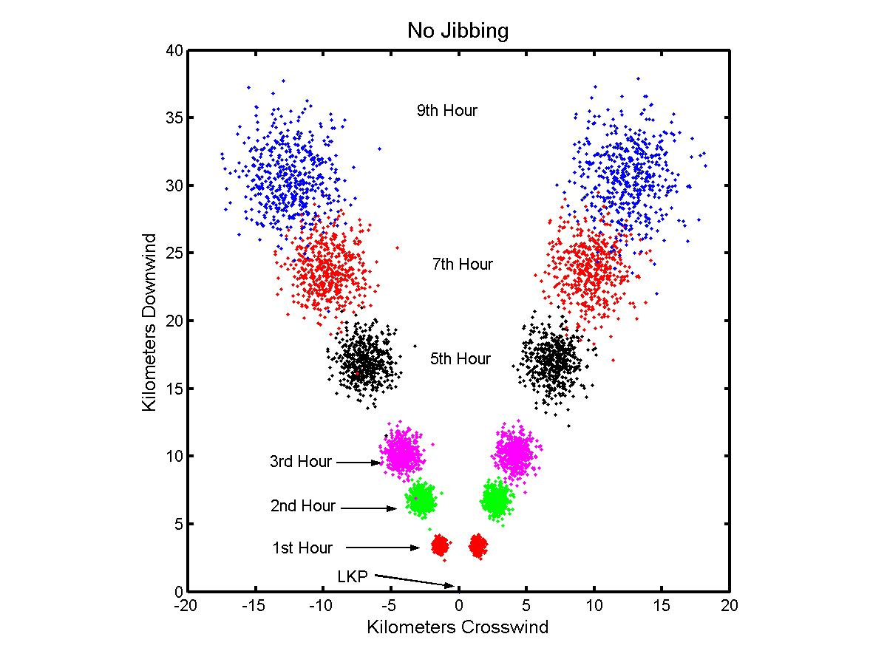

Figure 1. The probability distributions at 0, 1, 2, 3, 5, 7 and 9 hours after start of 1000 replication of a flat bottom skiff in 30 m/s of south wind. The percent change of gybing per hour per replication was set to zero.

In Figure 2 the percent change of gybing is now set to 0.5%, which is very close to that observed for the v-hull open skiff. Clearly a few replications are now gybing and as a result there are a few replications that are between the major left and right distributions. However, the distribution on whole remain essential bimodal.

0.5% Gybing per Hour
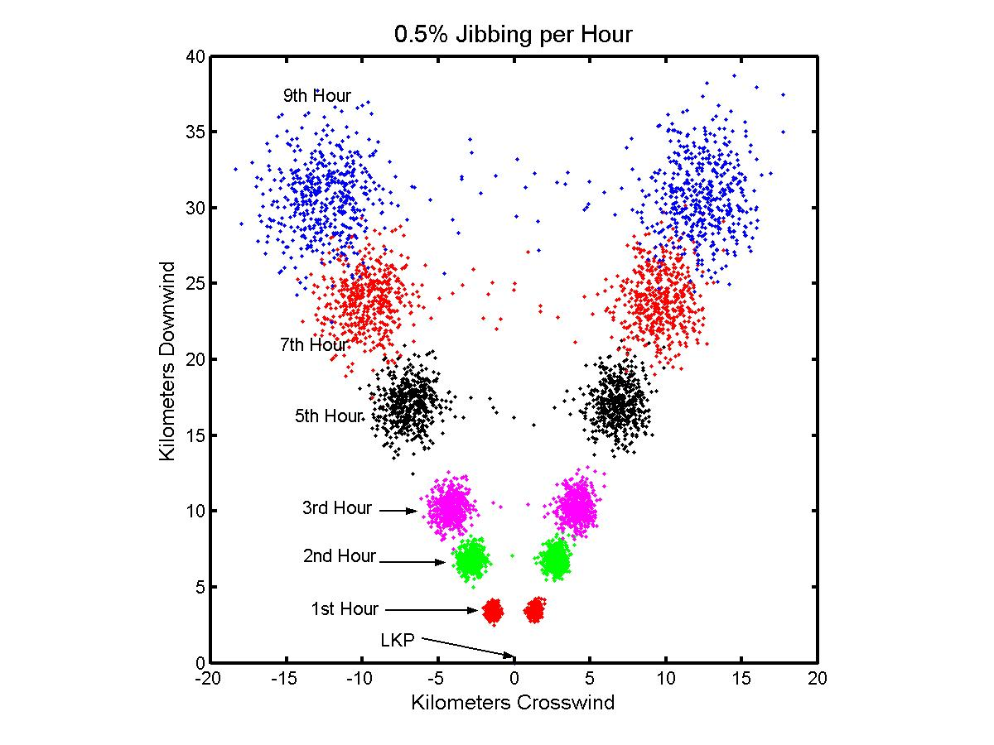
Figure 2. The probability distributions at 0, 1, 2, 3, 5, 7 and 9 hours after start of 1000 replication of a flat bottom skiff in 30 m/s of south wind. The percent change of gybing per hour per replication was set to 0.5% per hour per replication after the first hour drift.

For Figure 3 the percent change of gybing was double to 1.0 %. If we assume that the observed gybing rates of 0.1% and 0.6% per hour represent the lower bounds for gybing, then 1 to 5% is perhaps the range where covering the actual frequency of gybing. At this rate of gybing there are replications between the two major left and right distributions.

1% Gybing per Hour
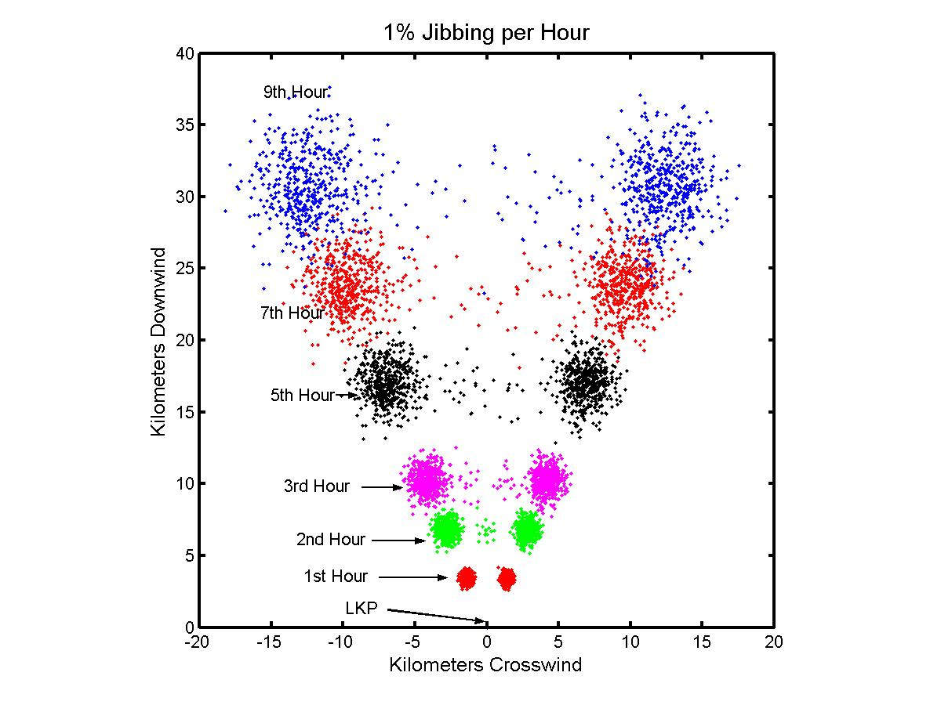
Figure 3. The probability distributions at 0, 1, 2, 3, 5, 7 and 9 hours after start of 1000 replication of a flat bottom skiff in 30 m/s of south wind. The percent change of gybing per hour per replication was set to 1.0% per hour per replication after the first hour drift.

And for figure 4, the percent change of gybing was increased to 5.0%. Now at 5% change of gybing the middle of the distribution is being populated with a significant number of replications. At the second hour a small distribution of O(50) replications (or about 5% of the 1000) is now located half way between the two major distributions. The next hour (3rd) there are two intermediate distributions both of the O(50) replications. Roughly, half came from the adjacent major distribution and half came from the center distribution.

Another effect is apparent in figures 4 and 5. Those replication that have jibed and are filling in the area between the two major outside distributions line along a straight line between the centers of the two outside distributions and not an arc (figure 4). The pathways of a replications that jib, have less net displacement from LKP then those replication that haven’t jib. The jibing replications zigzag their way downwind, thereby have less net displacements, that those replications that remain on their original tacks (see Figure 5).

Both the US Monte Carlo search planning tool - CASP and the Canadian analytic search planning tool - CANSARP use arc shaped distributions between the left and right divergence angles, which are contrary to what is shown here.

5% Gybing per Hour
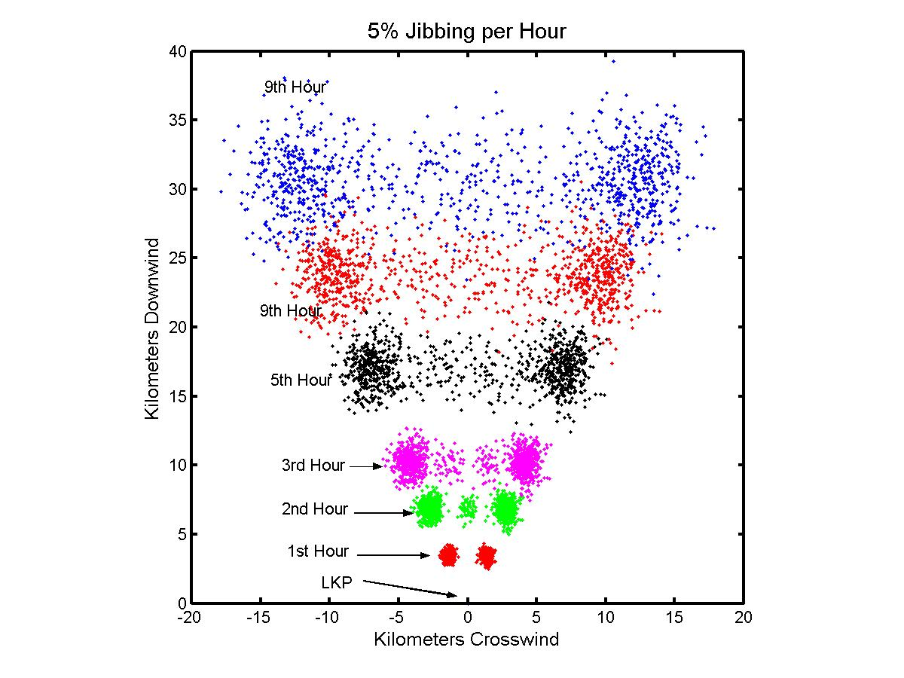

Figure 4. The probability distributions at 0, 1, 2, 3, 5, 7 and 9 hours after start of 1000 replication of a flat bottom skiff in 30 m/s of south wind. The percent change of gybing per hour per replication was set to 5% per hour per replication after the first hour drift.

5% Gybing per Hour
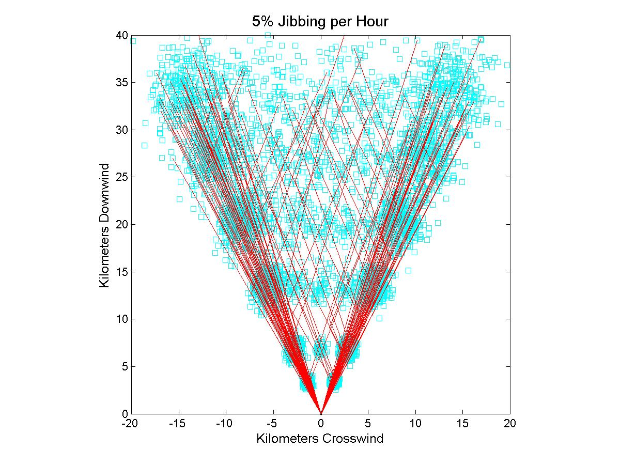

Figure 5. The probability distributions (magenta squares) at 0, 1, 2, 3, 5, 7 and 9 hours after start of 1000 replication of a flat bottom skiff in 30 m/s of south wind. The percent change of gybing per hour per replication was set to 5% per hour per replication after the first hour drift. Red lines are every 10th track line for the 1000 replications from zero to 9 hours.

In the figures 6-8, we are now looking at unrealistically high frequencies of gybing (10% to 100% per hour). At 10% (Figure 6) and 50% (Figure 7) gybing per hour the flatten non-arc distributions are also in evident. At this higher rates of gybing the two outer distributions have been severely decimated and a more over all distribution is more continuous from left to right.

10% Gybing per Hour
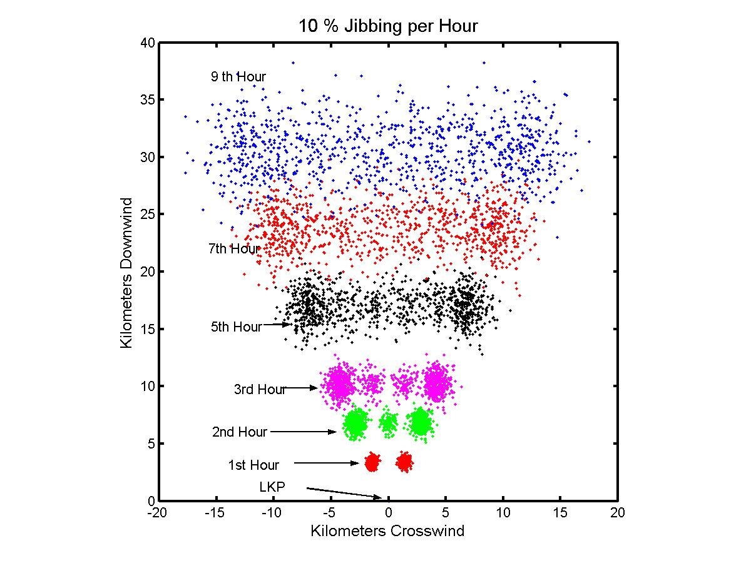

Figure 6. The probability distributions at 0, 1, 2, 3, 5, 7 and 9 hours after start of 1000 replication of a flat bottom skiff in 30 m/s of south wind. The percent change of gybing per hour per replication was set to 10% per hour per replication after the first hour drift.

The upper statistic limit for jibing is a 50% change of jibing every time step. The effects of gybing every hour are shown in figure 7. This nicely illustrates the Central Limit Theorem, which will bring the replications back towards the downwind centerline. While this leeway category (small skiffs) has considerable leeway divergence (30 degrees) the effect of constant jibing is to completely cancel effects of divergence after about nine hours.

The upper mathematic limit for jibing is forcing the replication to jib every time step. This is illustrated in figure 8 for completeness.

50% Gybing per Hour
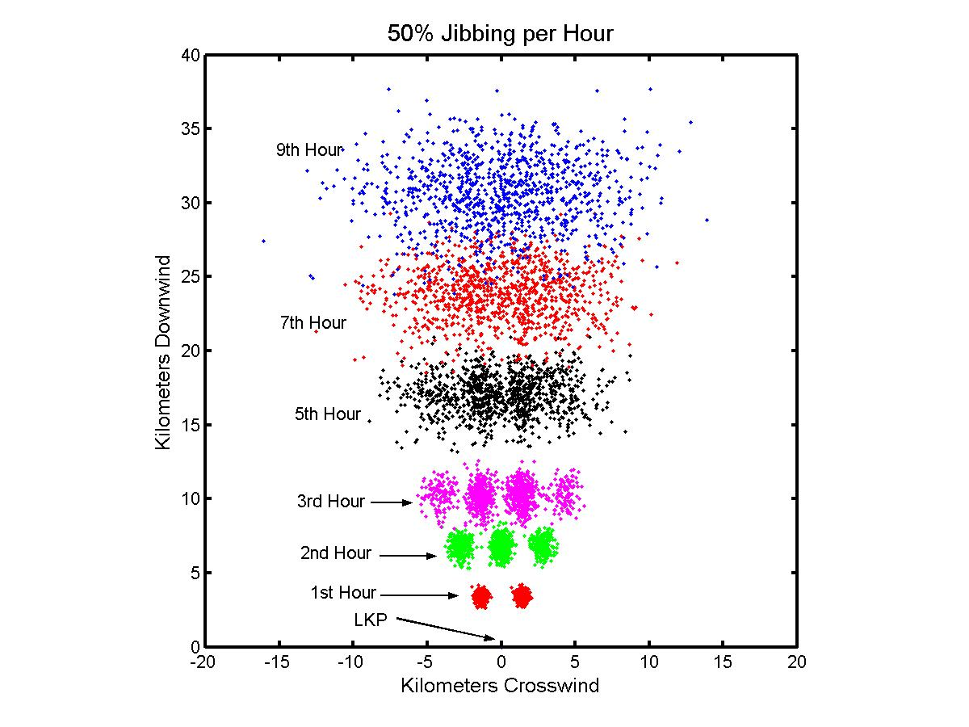

Figure 7. The probability distributions at 0, 1, 2, 3, 5, 7 and 9 hours after start of 1000 replication of a flat bottom skiff in 30 m/s of south wind. The percent change of gybing per hour per replication was set to 50% per hour per replication after the first hour drift.

Table 1.
Summary of Displacement Statistics
for the Constant Wind Direction Example

Chance of Gybing | Down Disp  (km) | Cross Disp  (km) | Net Disp  (km)
0.0% | 34.0 + 0.1 | 13.9 | 36.8
0.5% | 34.0 + 0.1 | 13.6 | 36.8
1.0% | 34.0 + 0.1 | 13.3 | 36.6
5% | 34.0 + 0.1 | 11.0 | 36.1
10% | 34.0 + 0.1 | 9.3 | 35.6
50% | 34.0 + 0.1 | 3.8 | 34.3
100% | 34.0 + 0.1 | 1.3 | 34.2

100% Gybing per Hour
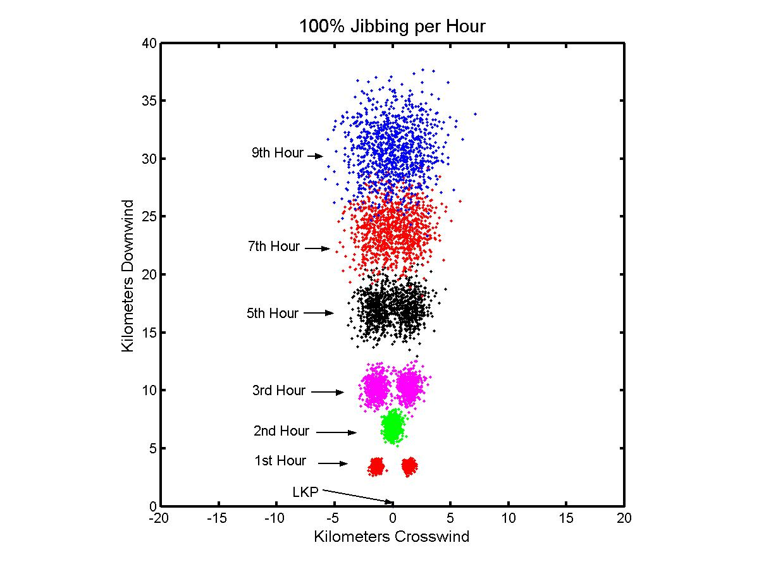

Figure 8. The probability distributions at 0, 1, 2, 3, 5, 7 and 9 hours after start of 1000 replication of a flat bottom skiff in 30 m/s of south wind. The percent change of gybing per hour per replication was set to 100% per hour per replication after the first hour drift. After the first hour, each replication was forced to jib every hour.

- The Effects of Wind Shift Gybing on Search Area Distributions

We will use the exact same example as above (Boston Whaler, 30m/s of wind, no sea currents, 1000 replications all starting at (0,0) at time zero). To illustrate the effect of gybing occurring at a wind direction shift, the wind was shifted 180 after 9 hours of drift, and the wind then blew from the north at 30m/s for the next 9 hours. So, we have 9 hours of winds from the south followed by 9 hours of winds from the north. We have chosen 1% change of gybing during the period of constant wind direction and 10% (Figure 9) and 50% (Figure 10) chance during the wind shift.

Both Figures 9 and 10 illustrate that gybing occurring at a wind shift has the opposite affect on the search area distribution as that of gybing that occurs during period of relative constant wind direction. The effect of gybing associated with a rapid wind shift is that the jibbed replications will be the outliners spreading out the distribution and non-jibed replications will actually be converging towards each other. While gybing associated with rapid shifts in wind direction are problem relative rare, there possible should not be discounted since the size of the search area distribution is greatly increased by even a slight possibility of this phenomena.

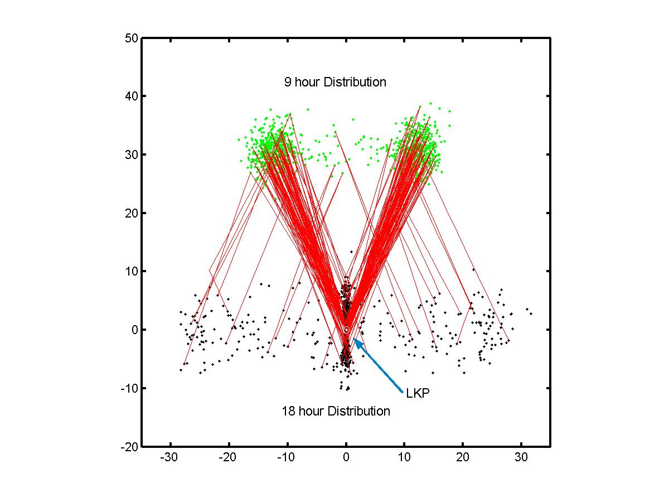

Figure 9. The probability distributions of 1000 replications of a flat bottom skiff at 9 are shown as green dots and at 18 hours as black dots. Wind was 30m/s from the south for the first 9 hours and 30 m/s for the second 9 hours. The percent change of gybing per hour per replication was set to 1% per hour per replication after the first hour drift for the two periods of constant wind direction. The percent change of gybing during with wind shift was 10%.

1% Gybing per Hour, 50% Chance during the Wind Shift
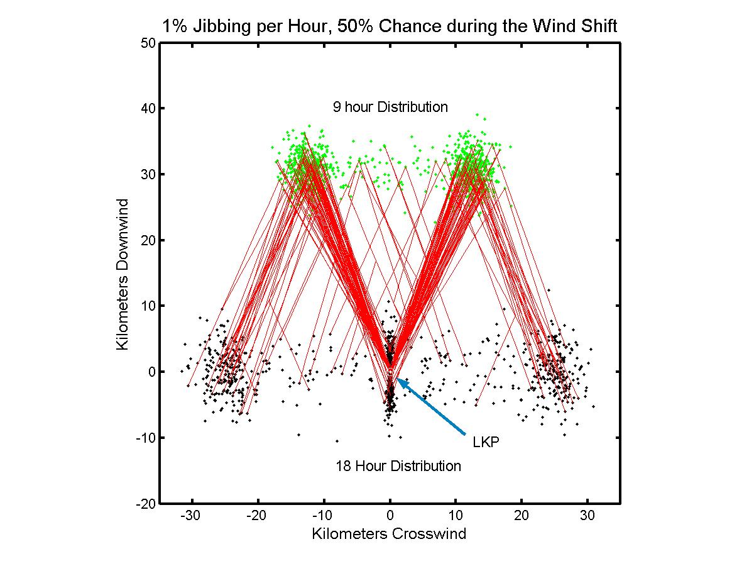

Figure 10. The probability distributions of 1000 replications of a flat bottom skiff at 9 are shown as green dots and at 18 hours as black dots. Wind was 30m/s from the south for the first 9 hours and 30 m/s for the second 9 hours. The percent change of gybing per hour per replication was set to 1% per hour per replication after the first hour drift for the two periods of constant wind direction. The percent change of gybing during with wind shift was 50%.

Conclusions and Recommendations

The primary factors determining search area distributions are: (1) size and shape of the initial distribution; (2) sea surface currents; (3) leeway divergence and (4) leeway speed of the search object(s). Gybing is a secondary factor that affects the leeway divergence primary factor. And gybing and swamping / capsizing events are secondary factors that affect leeway speed and also leeway divergence (Allen and Fitzgerald, 1998).

Taken together, these second order leeway behaviors change the first order behaviors of leeway speed and divergence. Accurate modeling of search areas depends upon having accurate models of gybing, swamping and capsizing.

(Recommendation 1)

Re-visit the 1995 Grand Banks capsizing – swamping event using 2-D wave fields estimated from the wind fields to develop primary model of swamping and capsizing events.
(Recommendation 2)

Develop or refine the leeway measuring technique that isn’t biased against gybing, swamping or capsizing. Test the technique under normal conditions of 0-20 m/s of wind speed.
(Recommendation 3)

Continue field studies of a variety of leeway objects under normal to extreme (20 to 30 m/s of wind speed) conditions with the new or refined techniques to gather data on jibing, swamping, and capsizing of SAR objects.

(Recommendation 4)

Update jibing, swamping, and capsizing models based upon finds from recommendations 1 and 3.

(Recommendation 5)

Implement jibing, swamping and capsizing models into CG SAR planning tool.

